Exercising Leadership in the Season of Pentecost - Fiery, Courageous Conviction
The Rev. Jim Strader-Sasser
When Pentecost Day arrived, they were all together in one place. Suddenly a sound from heaven like the howling of a fierce wind filled the entire house where they were sitting. They saw what seemed to be individual flames of fire alighting on each one of them. They were all filled with the Holy Spirit and began to speak in other languages as the Spirit enabled them to speak. (Acts 2: 1-4)
God's Holy Spirit's fiery work and presence is grounded and fueled in conviction. (Bishop Robert Wright, May, 24, 2017)
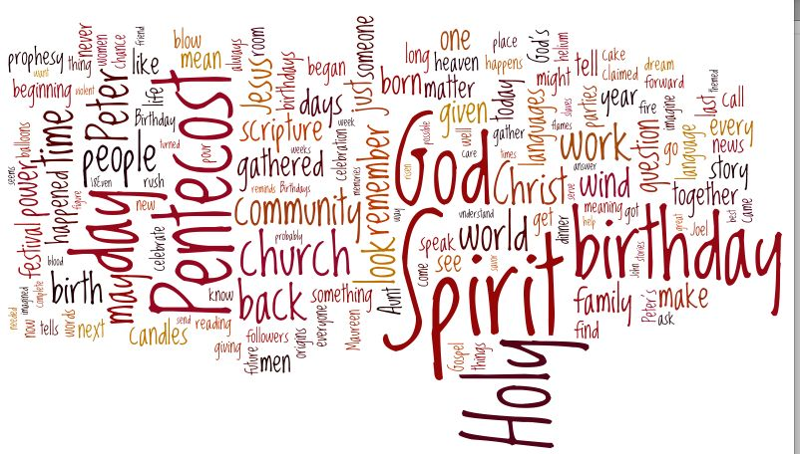
The Rt. Rev. Robert Wright – 10th Bishop of the Episcopal Diocese of Atlanta defines leadership in these terms. “Leadership is the true capacity to mobilize people to address tough problems, especially those they refuse to acknowledge or intentionally avoid.” (Wright, 2017) Bishop Wright clearly distinguishes between leadership behaviors in contrast to accomplishing tasks from positions of authority. Leadership is an activity, not a job position or set of personality traits. (Richman, 1988) Leadership occurs when someone, regardless of title or role, observes, analyzes, and chooses courageously to intervene into the turbulent realities of their situation. Persons exercising leadership disallow resistant barriers to prevent their communities from accomplishing the purpose they claim to possess. Leadership is an engaged creative process, not an authority endowed upon someone through ordination vows or societal status.
Episcopalians need to exercise such leadership. Forming committees and passing resolutions prove themselves to be usually ineffective to overcoming systematic barriers to change. How relevant have denominational and diocesan convention attempts to encourage vitality been at local levels? To quote Albert Einstein, “You cannot solve a problem with the same consciousness that created it.”
There are a vast number of adaptive challenges Episcopal communities of faith confront in their settings. Secular crises include opioid epidemics, racism and cultural prejudices, environmental catastrophes, and an overt sense of anxiety in their faith communities. People thus doubt their congregations possess capacities to achieve the Church’s hope “to live with confidence in newness, and fullness of life, and to await the coming of Christ in glory and the completion of God's purpose for the world.” (The Episcopal Church, 1979, p. 861).
Time and again, priests and deacons, and vestries as well as diocesan commissions express their fear of being unable to confront congregational decline and aging demographics as they address costs of maintaining buildings and increased costs of human resources. Bishop Wright reminds us that we have the wisdom and resources to adaptively lead in these complicated times. “Effective leadership is about holding on to one’s sense of purpose.” (Wright, 2017)
We should choose to deconstruct and reorient the terms of our reality. The challenges Episcopalians and other mainline denominations confront are transformational opportunities. Life, death, and resurrection issues require congregations to undertake pragmatic, psychological, and spiritual innovations. Fierce conversations are necessary. Fear and loss are realities that our emerging and established faith communities should no longer set aside. Some churches will cease to exist as they have for long periods of time. This fact is a true pastoral and organizational reality. And, clerics and lay people alike who yearn to exercise adaptive, Christ Jesus inspired discipleship must dig some very deep holes into the grounding of our Christian faith. God is beckoning us to focus on eyes and ears and hearts on cultivating Spirit-led creativity. Such soulful work requires collaborating with intentional contemplative and actionable devotion. Such life-giving, liberating, and loving work, as our Presiding Bishop states, requires more than encouragement. (Curry, 2016). This sort of evangelism drills through our passions and anxieties into the depths of our purpose for being Church. Such leadership disrupts much of what we Anglicans often most treasure, (tradition, pastor-centered authority, parochial identity, and unreasonable levels of protection, direction, and control).
Luke tells us that Jesus took the disciples only as far as Bethany for the Last Supper as well as on Ascension Day. The crucified, risen and soon to be ascended Christ Jesus declares that his followers are to proclaim repentance and forgiveness of sins in his name to all nations, beginning in Jerusalem. (Luke 24:47) When Jesus’ feet leave the ground and he ascends is a pivotal moment. Christianity’s transformational work truly began. Then, and now, Jesus calls us to his mission and gets out of the way so that we can indeed become “The Way.” The Spirit joins alongside us to fire us up and drive us into the wilderness of our own encounter with the World and God alike. Jesus remains with us in Word and Sacrament yet are gaze is often upward.
We are today’s witnesses to these Pentecostal events. How shall we then live into these responsibilities? Let’s begin with prayer. Not just prayer from our prayer books or extemporaneous thoughts and words. We start intentionally with the end in mind even as God invites us to join in undertaking tasks that we understand and problems that we don’t. Prayer is a platform for assuring our purpose. Who is God beckoning us to be in unity within the church, across the street, and in our town? What are the means whereby we can develop deeper relationships with God and neighbor alike? Our church facilities offer sacred space to let our overwrought minds center on God’s providence rather than our own emotions. Let’s develop practices of prayer without words other than thanksgiving and repentance. Our efforts to do something world-changing without establishing such sacred space lacks essence and centered confidence. Prayer and meditation are essential planning activities in this initial stage.
Then, we implement our prayerful plans into action. Experimenting with solutions based upon previous successful learning often work well, at least to start. Coincidentally, we can try to accomplish something off the wall that’s neither too costly or too distracting. Being bold as we go into the world will inevitably produce small initial victories. The quickest and most reaffirming results will occur simply by introducing ourselves and listening to other people’s narratives and needs. Establishing quantifiable goals and objectives that will help guide our path without dictating our plan are relevant too.
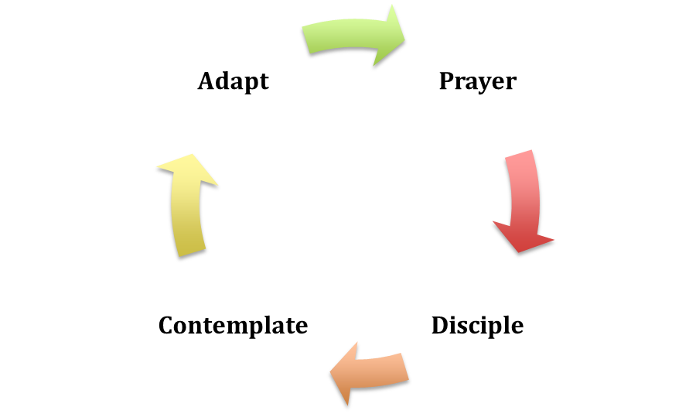
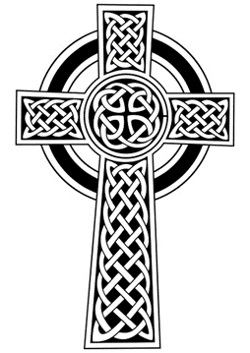

We then actively consider our efforts. What seems to be on track? What surprises us? How has God’s Spirit jumped into the middle of our plan and reimagined it for us? Who are new partners in a shared enterprise? What’s lighting up our brains with possibility and uncertainty? Again, silence is a key element of this step. Letting a process speak for itself without impressing biases upon it is essential. And, the group should have experts who are willing to be vulnerable to admit to one another what they are learning. Reflective analysis exhibits both objective thinking and hope. Allowing time for purposeful work and ministry to occur and undergo scrutiny requires perseverance, especially if the work the community is undertaking is adaptive in nature. And, we must ensure that there is enough heat in place to make sure that people do not falter in the wilderness of uncertain or undesirable events.

The final phase of this four-fold Celtic Cross is determining what, when, where, why and how we should adapt our purpose and plan. What interventions are now necessary? Is there unfinished work or new opportunities that have presented themselves. What have we learned and what remains unlearned? Frequently, organizations claim victories and return back to life as it was when the work began. Perseverance to continue the work is essential. Throughout this process, conflict is both healthy and risky. Participants must strive to keep one another in a dynamic learning range. Commonly, especially when anxiety levels are high, someone(s) in the group seek(s) to sabotage the work or evacuate the process. Christians must be patient with one another without exchanging facts for niceties.
21st Century Christian Reformation is tough. Pastoral care is important and not the driving motivator for these endeavors. Identifying tough challenges and motivating people to address and overcome them is at the heart of communal transformation. In sum, a Prayerful, Discipleship, Contemplative, Adaptive (PDCA) method of Anglican Evangelical Leadership provides a purposeful, objective, and spiritual means for accomplishing The Church’s mission as communities of faith and praxis wrestle with technical and adaptive challenges alike.
Living into Jesus Christ’s Gospel creates initial and ongoing challenges. Original thinkers don’t worry about such setbacks. (Grant, 2016) The original apostles were driven by their desire to proclaim the Good News to those persons who most needed to hear it. The nature of the work most truly emerges out of its evangelical dedication and the heartfelt observations of its members. There is almost always one person with a purpose who inspires their community to become Christ’s incarnation in today’s world. Who is that person in your congregation?
Allow me to quickly offer one example of such adaptive learning. A parish in Central Pennsylvania had a member who was working on an academic project in Greece. She observed the heartache and fear Syrian and other refugees from the Islamic world were suffering while fleeing their homelands’ destructive violence. She elected to exercise leadership and began volunteering at a local refugee shelter in Athens. She connected with her friends back in the United States to support her efforts to buy food and other supplies. In turn, one of her friends sought a donation from the parish’s Outreach funds. The Outreach Committee prayed and planned more broadly as to how this parish could live more fully into its purpose of being a merciful “Jubilee” Episcopal parish focused on the needs of suffering people around the world.
An initial $300.00 gift soon became $1500.00 Charitable gifts grew radically. And, the parish engaged its children with children from the refugee center. Parishioners shared the Good News of this outreach project with their neighbors who subsequently became involved. One of the benefits of the effort was the development of a calendar that was produced by the people in the refugee shelter and a local printer in Athens. More funds were raised and connections established! Christ’s Gospel is being proclaimed because a few people with a common purpose expressed God’s love in a unique way because of one person’s intention.
The present truth is that this project now requires further contemplation and adaptation. The project’s founder is returning to the United States. The parish’s vestry and incoming rector and the parish will need to evaluate their work as they consider entering into a deeper relationship with God, one another, and the refugees in Athens. This heartfelt mission may continue come to its logical end. Regardless, Syrian refugees continue to pour into Athens and other European cities even as our nation does it best to deny their presence among us.
The Acts of the Apostles inform us that the apostles didn’t merely remain in Jerusalem. Jesus’ first disciples were faithful in prayer even as they set out on their purpose to proclaim to Good News of God’s Reign throughout the Roman Empire. They disagreed on any number of practices and protocol even as they returned to a shared dedication to become Christ Jesus’ faithful disciples. We don’t need to unnecessarily relive the conflicts of Corinth or Galatia. And, conflict, like The Cross itself, is a transformational opportunity to deny death in favor of new life. Today, instead of letting our parishes ascend into the comfort of comfortable worship and passive engagement, let us exercise leadership. This time is ripe to ponder God’s purpose for our faith communities while beginning a process of prayer, discipleship, contemplation, and adaptation that’s courageous and demonstrates fiery Christian conviction.

Bibliography
Curry, T. R. (2016, September 16). The Jesus Movembet. Retrieved from The Episcopal Church: http://www.episcopalchurch.org/library/video/jesus-movement
Grant, A. (2016, February). TED. Retrieved from The Surprising Habits of Original Thinkers: https://www.ted.com/talks/adam_grant_the_surprising_habits_of_original_thinkers
Richman, T. (1988, October 1). Leadership Expert Ronald Heifetz.
Scanlan, A. C. (2017, May 19). A Chicken in Every Pot. Retrieved from Compass Points - Mapping The Way: http://compasspointsmappingtheway.blogspot.com/2017/05/a-chicken-in-every-pot_19.html
The Episcopal Church. (1979). The Book of common prayer and administration of the sacraments and other rites and ceremonies of the church : together with the Psalter or Psalms of David according to the use of the Episcopal Church. . New York: Seabury Press.
Wright, R. (Performer). (2017, May 23). Going Not Gazing. Episcopal Diocese of Central Pennsylavania Clergy Days, State College, Pennsylvania.

